**Project 2: Directions. Usage Research Data Elicitation and Analysis**

**Product Concept Statement**

The proposed product is a mobile app which will support the efforts of health care students who are participating in their supervised clinical practice experiences (SCPEs).  Several medical professions require student practitioners to document their daily clinical experiences as part of their training for both graduation and licensure.

Current clinical documentation software exists largely in the desktop/laptop computer format, with a gap in the offering of a mobile app. O’Connor and Andrews (2018, p. 172) state that the use of mobile apps to enhance clinical education has not been explored, and these apps could benefit the acquisition of knowledge and skills in clinical settings.

This project will be aimed at the mobile device-savvy Gen Z students as they experience the clinical environment. Pre-filled questions and multiple-choice selections will be employed when possible, with spaces available for students to briefly discuss their clinical experiences each day.

**Preparation for Usage Research Data Elicitation**

The team met to discuss plans for data elicitation to learn more about the work practices of both faculty and students with respect to logging patient encounters during SCPEs.  As advised by Hartson & Pyla (2019, p. 124) the team researched the field of Physician Assistant Studies, the concept and rationale of SCPEs, as well as terminology used by practitioners in the field. According to Hartson & Pyla (2019), researching in advance will give the team a better understanding of the work practices as well as shorten the amount of time utilized in data elicitation.

Tactical goals (Hartson & Pyla, 2019, p. 122) for data elicitation from the School perspective are to learn:

* How clinical rotations work for the Physician Assistants Studies program *(work practice ecology, p. 122)*
* What defines a SCPE, requirements of the program, school and the accrediting bodies, and other possible licensure requirements *(work practice ecology, p. 122)*
* How SCPEs are obtained (school assigned, student arranged, etc) *(information hierarchies and work flows, p. 122)*
* Where SCPE sites are located, along with the number and types of SCPEs students must complete
* Where SCPEs are positioned within the PA curriculum *(information hierarchies and work flows, p. 122)*
* What would make clinical documentation more streamlined for faculty *(information hierarchies and work flows, p. 122)*
* What sort of documentation method for patient encounters is currently being used during SCPEs, and how can one improve upon it *(understanding market trends and forces, p. 123)*
* What are other PA programs using for documentation during SCPEs *(understanding market trends and forces, p. 123)*

Tactical goals for data elicitation from the student perspective are to learn:

* How students view the SCPE *(work practice ecology, p. 122)*
* What are some challenges to patient encounter documentation during SCPEs *(work practice ecology, p. 122)*
* How often are students expected to complete clinical documentation *(information hierarchies and work flows, p. 122)*
* If/how feedback is offered by instructors *(information hierarchies and work flows, p. 122)*
* What would make clinical documentation more user friendly and convenient for students to complete *(understanding market trends and forces, p. 123)*
* What are peers using at other institutions *(understanding market trends and forces, p. 123)*
* What documentation methods are currently being used and how could they be improved

upon *(understanding market trends and forces, p. 123)*

**Client and User Interviews**

  The team met with one client representative and two student users, garnering a great deal of insight and useful data to use in development of the clinical documentation mobile app.

Client Contact

* Courtney Hartman, MPA, PA-C
* Director of Clinical Education, PA Program, Duquesne University  412.396.5916
* hartma10@duq.edu

Responsibilities

* Coordination and supervision of the Clinical Phase of the PA Program.
* Prepares syllabi and learning objectives for all courses in the Clinical Phase of the program.
* Provides analysis of supervised clinical practice experiences for appropriateness of settings, patient encounters, clinical skills, diagnoses, and competencies.
* Schedule required and elective supervised clinical experiences, coordinating the distribution of students for appropriateness of clinical experiences.
* Analyzes clinical curriculum outcomes for review at committee meeting and by the Program Director.
* Provides analysis of supervised clinical practice experiences for appropriateness of settings, patient encounters, clinical skills, diagnoses, and competencies.

Student Users

* Samantha Studentowicz (year 5) currently in her Women’s Health SCPE at UPMC Mercy Hospital
* Dennis DeStudent (year 5) currently in her Emergency Medicine SCPE at Allegheny General Hospital

**Building the WAAD**

Taking the data learned from client and student interviews, the team began making sense of the work activity by creating a Work Activity Affinity Diagram (WAAD), as described by Hartson & Pyla (2019, p. 154) with the goal of sorting and analyzing the sample of work activity notes.

Work activity notes are typed into a laptop, since it will make the analysis process more manageable for the team and will  “facilitate sharing, manipulating, and printing as needed” (p. 146).

Additionally, each work activity note is clear and specific, “retaining the original meaning and remaining true to the user’s intentions” (p. 147).

Once the cards are sorted and categorized hierarchically by emerging themes, the team compiles them into a spreadsheet for further analysis. The team starts with the full set of notes that were extracted from the raw usage research data (p. 151). This step will help the team to synthesize information gained from all of the inputs, as well as their own observations, and will contribute to a better understanding of the whole concept (Hartson & Pyla, 2019, p. 176). An example of notes taken to create the WAAD is presented below:

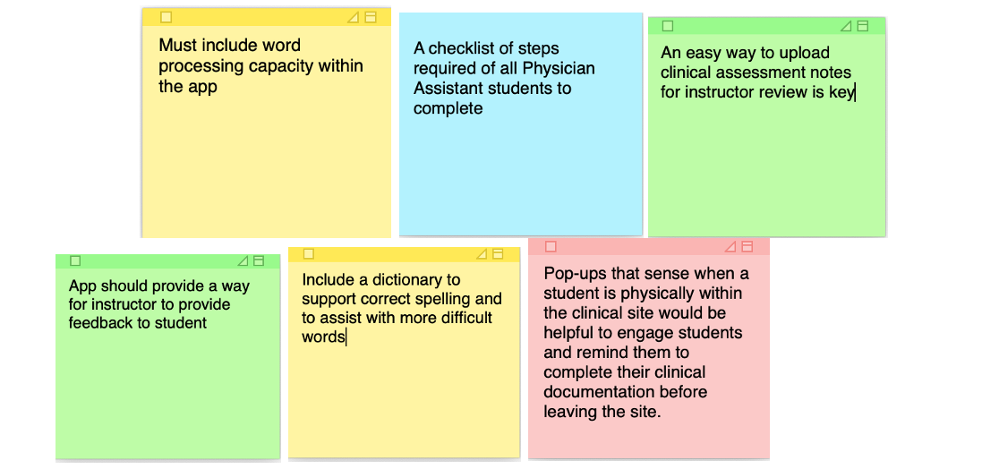

**Defining Work Roles and User Classifications**

The team identified three user classifications. User classification 1 (UC-1) is for users with a role which requires access to all aspects of the app.  UC-1 users may grant and revoke access to other users in UC-2 and UC-3.  The UC-2 classification is for users that require access to most areas of the app, but not all, nor can they revoke or grant access to others.  For UC-3 classification, users can interact with some data on the app and require some interaction with other users.  This project focuses primarily on two work roles (faculty and student). However, the team identified other work roles (Hartson & Pyla, 2019, p. 181), which include: technology coordinator, budget manager, clinical site manager, on-site preceptor, student affairs manager, and database coordinator.

* **Clinical Coordinator** - Oversees all clinical activities, including site assignments, clinical hours, managing on-side preceptors, faculty assignments, and student schedules. (UC-1)
* **Technology Coordinator** - Makes sure the technology is updated and working as intended.  The TC also fields questions regarding errors and app constraints. (UC-1)
* **Faculty** - Evaluates student notes uploaded to the app, and provides feedback when appropriate.  Will grade all assignments. (UC-2)
* **Student Affairs Manager** - Uploads student data to the app, enabling students to log into the app and ensures ease of use.  (UC-1)
* **On-site preceptor** - Supervises students as they conduct on-site clinical experiences.  Uses the app to view rosters of students who are assigned to them.  (UC-3)
* **Budget Manager** - Pays vendors for various services related to the app.  Also responsible for evaluating and remitting all on-site preceptor expenses.  (UC-3)
* **Database Coordinator** - Ensures student encounter notes are being securely uploaded from app to a tracking database, enabling faculty to track student progress and patient encounters. (UC-3)
* **Student User -** Uses the app to document their clinical experiences.  Interacts with faculty to obtain feedback and project grades.  (UC-3)

**Flow Model**

A workflow model between user roles is presented here, where you can observe “a high level view of how users in each work role and other system entities interact and communicate to get work done” (Hartson and Pyla, 2019, p. 187)

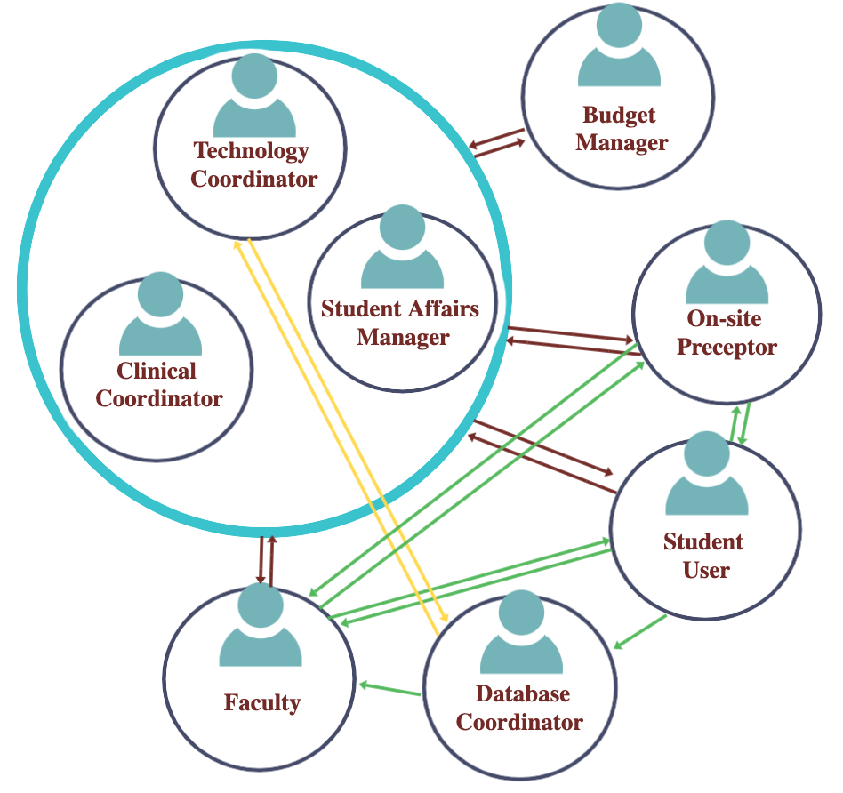

**List of Questions for the Interviews:**

Some of the interview questions were adapted from Peng et al. (2016). These authors examine user perceptions of mobile health apps based on a qualitative study, which will help us to get a better understanding of the perceptions and types of questions related to mobile apps and the medical field.

|  |
| --- |
| **Some Interview Questions are:** |
| 1. Can you tell us about the kinds of mobile phone apps you typically use? |
| 1. How frequently do you use them? |
| 1. Do you have any medical apps on your phone? |
| 1. How long ago did you download it/them? |
| 1. How frequently do you use it/them? |
| 1. What kind of medical/health apps do you think exist? |
| 1. For everyone that uses medical apps – What do you like about the app? What are your favorite features? What do you dislike about the app? Is there anything you would like to change about it? |
| 1. How has using a medical app increased your knowledge about the medical field? |
| 1. How has using a medical app supported you in your workplace? In what ways? |
| 1. If you don’t use any medical app, how do you think a clinical mobile app will benefit the student practitioners? |

**References**

Hartson, R., & Pyla, P. (2019).  *The UX Book: Agile UX design for a quality user experience*, 2nd ed. Cambridge, MA: Morgan Kaufmann.

O'Connor, S., & Andrews, T. (2018, 2018/10/01/). Smartphones and mobile applications (apps) in clinical nursing education: A student perspective. *Nurse Education Today, 69*, 172-178. [https://doi.org/https://doi.org/10.1016/j.nedt.2018.07.013](https://doi.org/https:/doi.org/10.1016/j.nedt.2018.07.013)

Peng, W., Kanthawala, S., Yuan, S. *et al.* A qualitative study of user perceptions of mobile health apps. *BMC Public Health* 16, 1158 (2016). <https://doi.org/10.1186/s12889-016-3808-0>