Competition:
  - Discoverability of everyday object

Scott Copley
Hair clippers
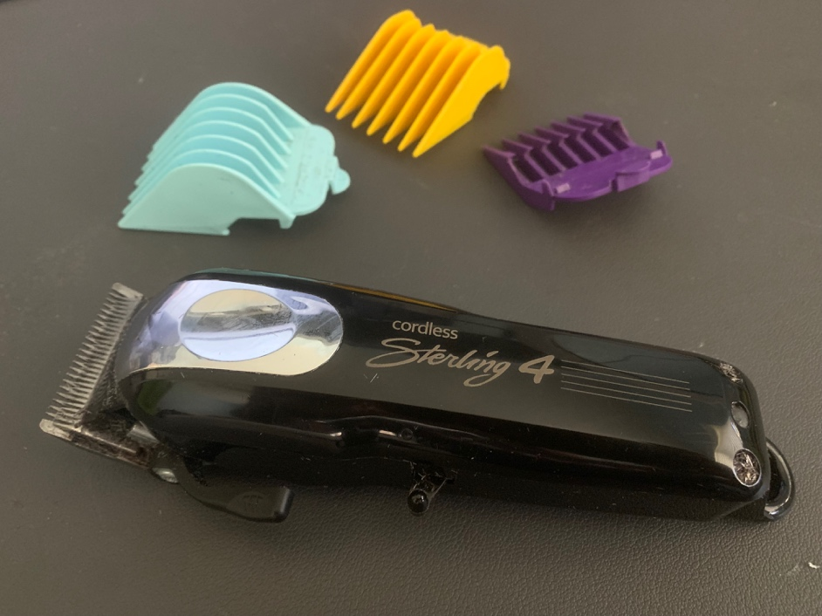
Figure 1. Cordless hair clippers

Justification
I selected hair clippers as my everyday object. Although I do not use it as frequently as a coffee maker, my laptop computer, or even my car, I use hair clippers with a fair bit of regularity. My first experience with clippers was not very positive since one of my earliest memories was my ear being cut by a barber using clippers to cut my hair. According to Norman (2013) “experience is critical, for it determines how fondly people remember their interactions.” Although I would imagine Norman was really talking about the experience a user of the object has, my early memory shaped how I felt about clippers as a somewhat dangerous device. The first time I trimmed my own hair with clippers was shortly after getting out of the Army. Having seen many people cut my hair with clippers while I was in the Army, I believed trimming my own hair would be a simple endeavor. It was not simple, and I ended up having to go to a professional barber to correct the numerous mistakes I had made with the clippers. Norman (2013, p. 8) discusses how crucial it is for us to understand how to use everyday objects, that by understanding how to use those objects, we gain a sense of feeling in control, or of pride and satisfaction.

Affordances
According to Norman (2013, p. 9) “an affordance is a relationship between the properties of an object and the capabilities of the agent that determine just how the object could possibly be used. In the case of my clipper device, the affordance is that it allows me to cut my hair. The sharp metal teeth on one end tells a user that the clippers are for cutting, and more specifically for cutting something fine, like hair. Norman (2013) discusses that affordances help people to know the actions a person should take without having labels or instructions. The shape of the colorful combs that came with the clippers leads a would-be user to understand that by snapping the guards onto the end of the clippers, space is created between the user’s scalp and the clippers. This affordance enables the user to safely cut their hair. Another affordance is a lever on the side of the device, which allows the user to move the clipper blades forward and backward to achieve a cut closer to the scalp.

Signifiers
While there are no actual signifiers such as arrows or words to say “turn on the device here” or an arrow to indicate which directly to move the lever for a closer clipper cut, the lever itself becomes an “accidental signifier” (Norman, 2013) for most users, letting them know that the lever adjust the clippers in some way. The only other moving piece on the device is the on/off switch, which again could be considered an accidental signifier in that the user may conclude that by moving the switch from one direction or another, the device will turn on if it is charged.

Mapping
The clipper device has clear mapping in that there are only two moving pieces, along with a port to plug-in the charging cord. The level to adjust the position of the clipper blades, the on and off switch, and even the colorful combs (or guards) are what Norman referred to as natural mapping (p. 20).
Feedback
Feedback, or communicating the results of an action (Norman 2013, p. 21), occurs when the clippers begin to run when the power switch is move to the on position. Though nothing tells the user which direction means on or off on the device, the user knows the device is running because of the buzzing sound it makes, along with the vibration coming from the blades moving back and forth rapidly. When the user moves the switch in the opposite direction, the device stops buzzing or vibrating, which is feedback that the device has been powered off. Another type of feedback occurs when the user moves the lever forward or backward and is able to see the blades move as the lever is adjusted. And the ultimate feedback occurs when the user touches their hair with the clippers and hears the vibration sounds change slightly as it cuts the user’s hair (and ultimately, hair falls to the floor). All of these types of feedback coordinate with the human nervous system of feeling, hearing, seeing, etc., as noted by Norman (2013, p. 22.)

References
Norman, D. A. (2013). Psychopathology of everyday things. In the design of everyday things: revised and expanded edition (pp. 1-36). New York, NY: Basic Books.

