Using Standardized Testing as a Predictor of Performance of Students Enrolled in a Bachelor of Science in Bachelor of Science in Nursing (BSN) Program

Scott Copley

Duquesne University
GREV 610 - Statistics II
Dr. Nandini Bhowmick
April 25, 2022

INTRODUCTION
During the Covid-19 outbreak, testing dates for standardized admissions exams such as the SAT or ACT became unavailable. As most segments of society (in the United States) went into lock-down in March 2020, high school students grew more and more concerned that their acceptances to colleges and universities could be in jeopardy. To assuage the fears of prospective students, and to avoid steep declines in enrollment, many institutions suspended standardized tests as a condition of admission for freshman class entry for Fall 2020. As the pandemic persisted, most institutions continued to suspend standardized admissions tests for entry to freshman classes for Fall 2021. Now in year-three of the pandemic, and in partial recovery, colleges and universities are questioning whether or not to continue waiving standardized exams, and rethinking what role do those tests play in student performance in academic programs?
Understanding the role of standardized test scores in collegiate performance could be mutually beneficial to the School of Nursing as well as Duquesne University as a whole. Success in BSN programs has typically been researched as performance on the licensure exam for nurses, the NCLEX-RN. According to Sayles, et al., (2003) performance on the NCLEX-RN is the ultimate proof of success in nursing program. In fact, research suggests (Alexander and Brophy, 1997 in Sayles, et al., 2003) that there is a strong correlation between NCLEX-RN performance and SAT verbal scores. While many studies center on NCLEX performance, there a few studies of how SAT/ACT performance may predict performance while enrolled in nursing programs. Since the gateway to enable a student to sit for the licensure exam is completion of a nursing academic program, how may we understand the role of standardized tests in the admissions process to these programs?

Mthimunye and Daniels (2019, p. 200) discuss the notion that a major goal of universities should be to predict academic performance of students. Subsequently, a major goal of schools of nursing should also be to predict academic performance of students. Understanding factors that affect student performance is a complex and difficult undertaking.
This project will look at one possible predictor of success: the standardized entrance test (SAT or ACT). Since one predictor of NCLEX-RN performance is a student’s GPA in BSN (Bachelor of Science in Nursing) programs, “success” will be defined as students who have remained enrolled in the program and also have a 3.0 GPA. As noted above, the School of nursing has waived standardized entrance exams for Fall 2020, Fall 2021, and Fall 2022. Performance data within the BSN program will only be available from students entering the program in Fall 2020 and Fall 2021.

RESEARCH QUESTIONS AND HYPOTHESES
Research questions
In researching the role of standardized entrance exams on student performance in BSN programs, the following research questions are posed:
RQ1: Do standardized tests of a student correlate to student performance and success?
RQ2: Is there a difference in performance of students who submitted SAT or ACT
scores?
RQ3: Is the student’s high school GPA a better predictor of performance?

Hypotheses
H1: There is strong correlation between student performance in BSN programs and
standardized admissions exams (SAT and ACT scores).
H2: Students who submitted standardized test scores have better performance in BSN
programs than students who did not submit scores (called “test optional).
H01: There is no significant correlation between student performance in BSN programs
and standardized admissions exams.
H02: Students who submitted standardized admissions test scores performed the same as
students who did not submit scores.
H3: High School GPA is a better predictor of academic success in college than
standardized admissions tests.
H03: High School GPA is not a better predictor of success in college than standardized
admissions tests.

METHODOLOGY

Sample
The sample was made up of 349 students who enrolled in the School of Nursing Bachelor of Science in Nursing Program in Fall 2020 and Fall 2021. (The distinction between male and female performance was not examined for this study.) The original intent of this study was to examine the possible difference in student performance between students who submitted standardized test scores and the students who did not submit test scores. Perhaps is the case in many studies, modifications to this study had to be made when it was discovered that all students enrolling in Fall 2020 and Fall 2021 submitted test scores.
Recognizing the need evaluate other performance indicators, this study moved to examining the high school GPA, the SAT Math, SAT Verbal, and ACT composite scores as predictors of success in the BSN program. A Pearson Correlation Coefficient test was conducted to examine whether or not there was a correlation between the performance indicators mentioned above. A univariate analysis of vanriance between subjects was also conducted.
4. RESULTS AND ANALYSIS
The mean GPA of the 349 students enrolled in the BSN program from 2020 and 2021 was 3.87; the mean SAT math score was 579 and the mean SAT verbal score was 594. The mean ACT composite score was 24. At the end of each academic year (combined) the overall college GPA mean was 3.32. These descriptive statistics indicate that students’ average high school GPA was significantly higher than their current average college GPAs, as shown in figure 2, below.
Figure 1: Sample of the student data used for this study.
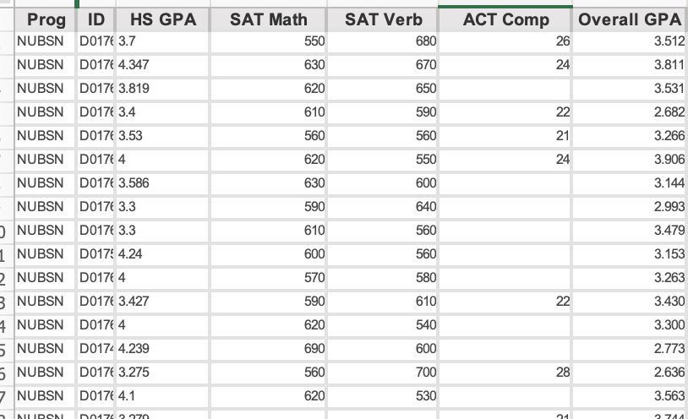

Figure 2: Descriptive statistic for BSN classes entering Fall 2020 and Fall 2021.
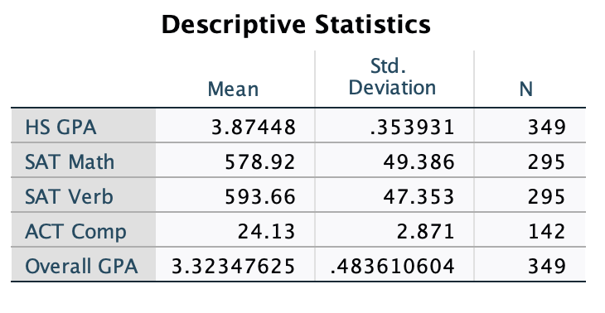
The Pearson Correlation Coefficient analysis revealed that there were some correlations between the performance indicators, though most correlations were not very strong. The strongest correlation was between the high school GPA and the overall (college) GPA at .34. There were no correlations between the performance indicators at the 0.05 significance level, and very weak correlations at the 0.01 significance level. The correlations at the 0.01 level between overall (college) GPA and SAT math was .20 and SAT verbal was .19, as indicated in Figures 3 and 4, below. The correlation between ACT and overall college GPA was not significant.

Figure 3: the Pearson Correlation Coeffcient between HS GPA, SAT Math, SAT Verbal, the ACT Composite and the Overall (college) GPA.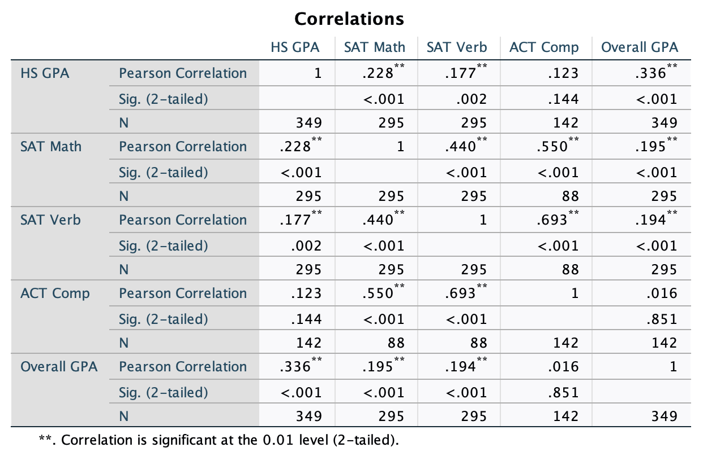
Figure 4: A simplified chart of correlations between Overall GPA and the other
performance factors.
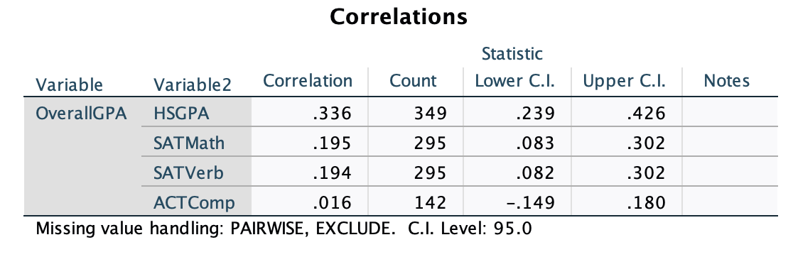

Figure 4: A scatterplot showing the relationship between the performance factors.

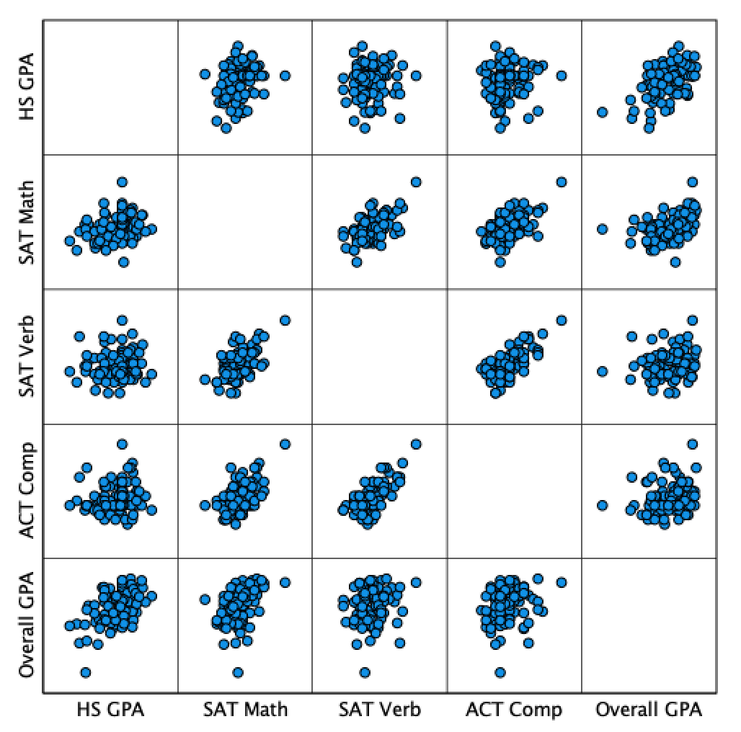

5. CONCLUSIONS

Although cognitive measures such as GPA and SAT/ACT scores are easily collected and have been trusted as more reliable due to their quantitative nature, Whipple & Dimitrova‐Grajzl (2018) refer to two noncognitive measures which may be a strong predictor of academic success: grit and person-environment fit (P-E fit). Grit refers to the amount of determination and passion a student has to reach their goals; P-E fit refers to the “degree to which a student’s needs, goals, and values align with those of the school and its members has been shown to influence student satisfaction and academic peformance (Whipple & Dimitrova‐Grajzl (2018). Unfortunately, there is no way to measure determination and grit of a particular student.
In looking at the hypothesis stated in the introduction of this study, there are some observations
Hypothesis 1: I must fail to reject the null hypothesis. There was not a strong correlation between standardized
H1: There is strong correlation between student performance in BSN programs and
standardized admissions exams (SAT and ACT scores).
H01: There is no significant correlation between student performance in BSN programs
and standardized admissions exams.
Hypothesis 2: I cannot accept or reject the null hypothesis since this portion of the data could not be considered. All students who enrolled in the BSN program submitted standardized test scores.
H2: Students who submitted standardized test scores have better performance in BSN
programs than students who did not submit scores (called “test optional).
H02: Students who submitted standardized admissions test scores performed the same as
students who did not submit scores.
Hypothesis 3: I can reject the null hypothesis. While the correlation is not strong, the most significant correlation of all occurred between the high school GPA and the overall (college) GPA.
H3: High school GPA is a better predictor of academic success in college than
standardized admissions tests.
H03: High school GPA is not a better predictor of success in college than standardized
admissions tests.

6. LIMITATIONS AND FURTHER RESEARCH
One limitation of this study is that it was limited to only one school of nursing, and a broader look at schools of nursing may be helpful. A longer-term approach to the data may be helpful, as our society appears to be heading toward a test-optional admissions criteria for many colleges in the United States. Perhaps in a few years, such an evaluation between students who submitted scores and those who did not submit scores could be conducted.
Another point of limitation could be how to define success in a Bachelor of Science in Nursing program. Informal conversations with student affairs professionals and nursing faculty yielded little agreement on how to define success. Some believed it was performance in specific classes such as Human Anatomy, or Pharmacology, while others defined it as a certain GPA. Many faculty see success in a BSN program as whether or not students pass the NCLEX-RN exam at the end of the program. It is clear that there are very few measurable predictors of student success in academic programs, and perhaps old ways of evaluating students for admission are beginning to be re-examined.

References
Krumrei Mancuso, E., Newton, F., Kim, E., & Wilcox, D. (2013). Psychosocial Factors Predicting First-Year College Student Success. Journal of College Student Development, 54, 247-266. https://doi.org/10.1353/csd.2013.0034

Mthimunye, K., & Daniels, F. M. (2019). Predictors of academic performance, success and retention amongst undergraduate nursing students : a systematic review. South African Journal of Higher Education, 33(1), 200-220. https://doi.org/doi:10.20853/33-1-2631

Sayles, S., Shelton, D., & Powell, H. (2003). Predictors of Success in Nursing Education. ABNF Journal, 14(6), 116-120. https://authenticate.library.duq.edu/login?url=https://search.ebscohost.com/login.aspx?direct=true&db=afh&AN=12835634&site=eds-live&scope=site

Whipple, S. S., & Dimitrova‐Grajzl, V. (2021). Grit, fit, gender, and academic achievement among first‐year college students [Article]. Psychology in the Schools, 58(2), 332-350. https://doi.org/10.1002/pits.22449

